Dataset documentation: Human-agent co-adaptation

**Manuscript:** Human-agent co-adaptation using error-related potentials

**Author: Stefan Ehrlich <stefan.ehrlich@tum.de>**

**Last revised: 07.02.2021**

If you use this dataset in your work, please cite this reference:

Ehrlich, S. K., & Cheng, G. (2018). Human-agent co-adaptation using error-related potentials. *Journal of Neural Engineering*, Vol. 15, Num. 6, DOI: 10.1088/1741-2552/aae069

# Introduction

This dataset was part of an experiment in which error-related potentials (ErrPs) were recorded using EEG from human subjects during human-agent interaction scenarios in order to mediate co-adaptation toward a consensus of both partners. In contrast to prior human-robot interaction scenarios there was no predefined superiority of the human partner over the robot. Both the human and the robot were required to adapt to each other and finally converge to a consensus in the given joint task.

# Conceptual approach

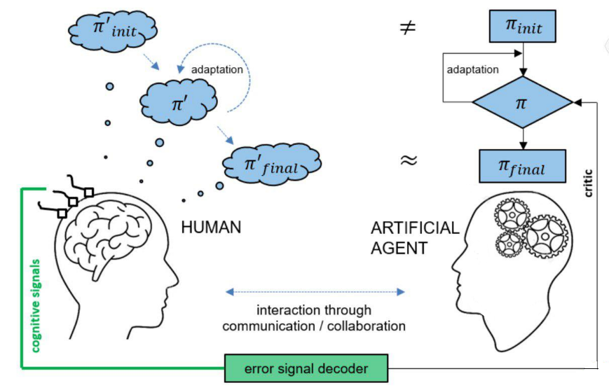When interacting with an agent, the human holds a mental model (belief) of the agent’s policy ‘ in order to predict its future behavior, which is based on prior expectations ’init and further adapted during interaction. ErrPs were decoded online from the neuronal activity of the human partner and provided a critique for guided adaptation of the agent’s actual model. This created a two-party co-adaptive system allowing both the human and agent to seek consensus in the form of an alignment of the human’s belief and the agent’s actual policy ’final ~ final

# Implementation

The approach was implemented in a guessing game experiment whereby a human subject and robot covertly select one of three given objects. Subsequently the robot produces a gaze pattern from which the subject has to guess the secret object. The subject’s brain responses are measured (marked in green) and used as a feedback signal to adapt the robot’s gaze behavior policy. Throughout the experiment, the subject may also adapt his/her prior belief ­­ about the robot’s gaze behavior policy. The overall system consists of three main parts: a human (1) who interacts with an artificial agent such as a robot (2) and a brain-machine interface used for decoding neurophysiological activity linking the two behaviors (3).

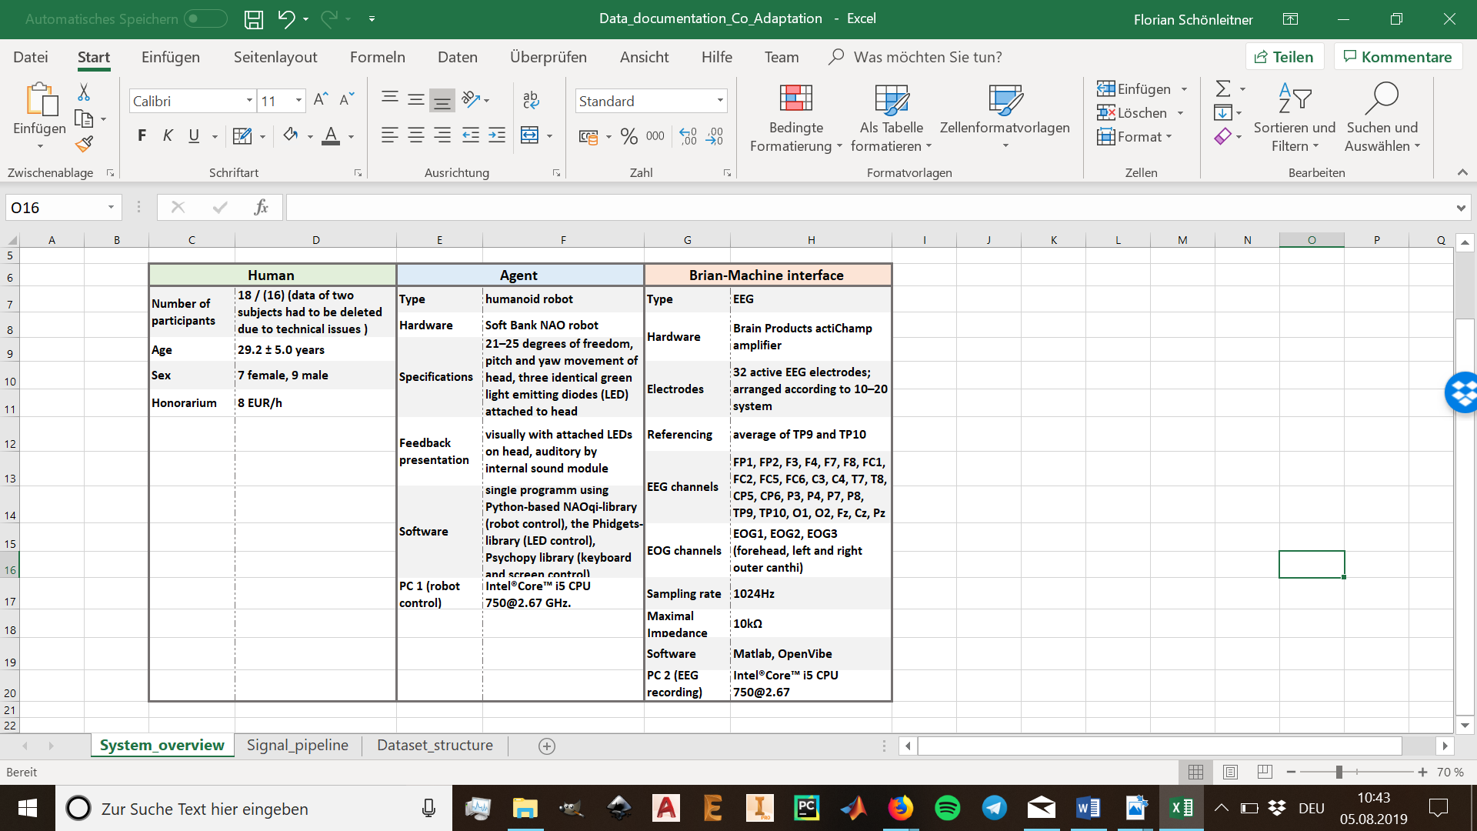

# Experimental design

## Experimental tasks:

Each experiment consisted of an open-loop calibration session (CALIB) which was followed by four closed-loop co-adaptation sessions (CORL-I to CORL-IV). Participants were asked to observe the robot and thereby guess the chosen objects from the robot’s gaze behavior.

## 

## Trial structure:

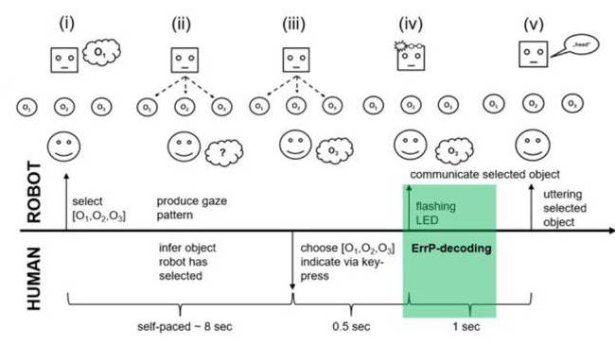One trial can be understood as one round of the guessing game and is divided in five chronological segments.

|  |  |  |  |
| --- | --- | --- | --- |
| ID | Duration | Human | Robot |
| (i) |  |  | Gaze at human, random selection of one object and initial gaze state |
| (II) | ~8 sec | Guess robot’s choice from gaze pattern | Produce gaze pattern based on current policy |
| (III) | 0.5 sec | Indicate the guess by a keypress | Stop gaze pattern and turn head back to human |
| (IV) | 1 sec | Record EEG signal to detect ErrPs | Visually indicate selected object by LED blinking |
| (V) |  |  | Give auditory feedback about selected object |

## Goal selection, gaze policies and action execution

Before any action execution, the robot has to choose one of three possible goals/intentions **.** This selection was implemented as a uniform random choice. The robot’s internal gaze policy was realized as a discrete state-space model with four states, with : gazing at selected object; ,: gazing at one of the other objects; and : gazing at human. An action is considered a transition from one gaze state to another or remaining in the current gaze state. The policy ­ determined the gaze behavior described by the probability of taking action in state (gaze transition from state to ). The decision for the next action was always performed by a weighted random selection among the four possible actions in the current state.

The robot gaze behavior resulted from a fixed mapping between the covert policy-states ­ and the overt action-execution states , depended on the selected object:

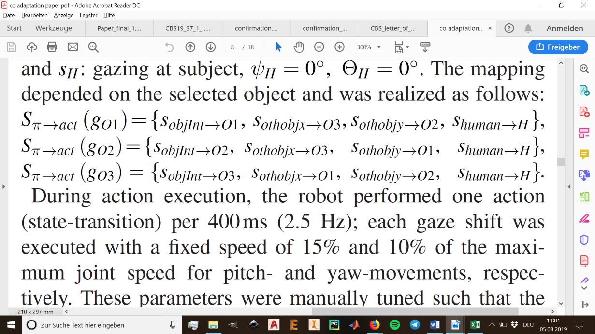

Robot head angles were predefined for each action-execution:

|  |  |  |
| --- | --- | --- |
| **Action** | **Pitch Ψ** | **Yaw Θ** |
| : gazing at | 25° | -20° |
| : gazing at | 25° | 0° |
| : gazing at | 25° | 20° |
| : gazing at Subject | 0° | 0° |

## Decoding ErrPs

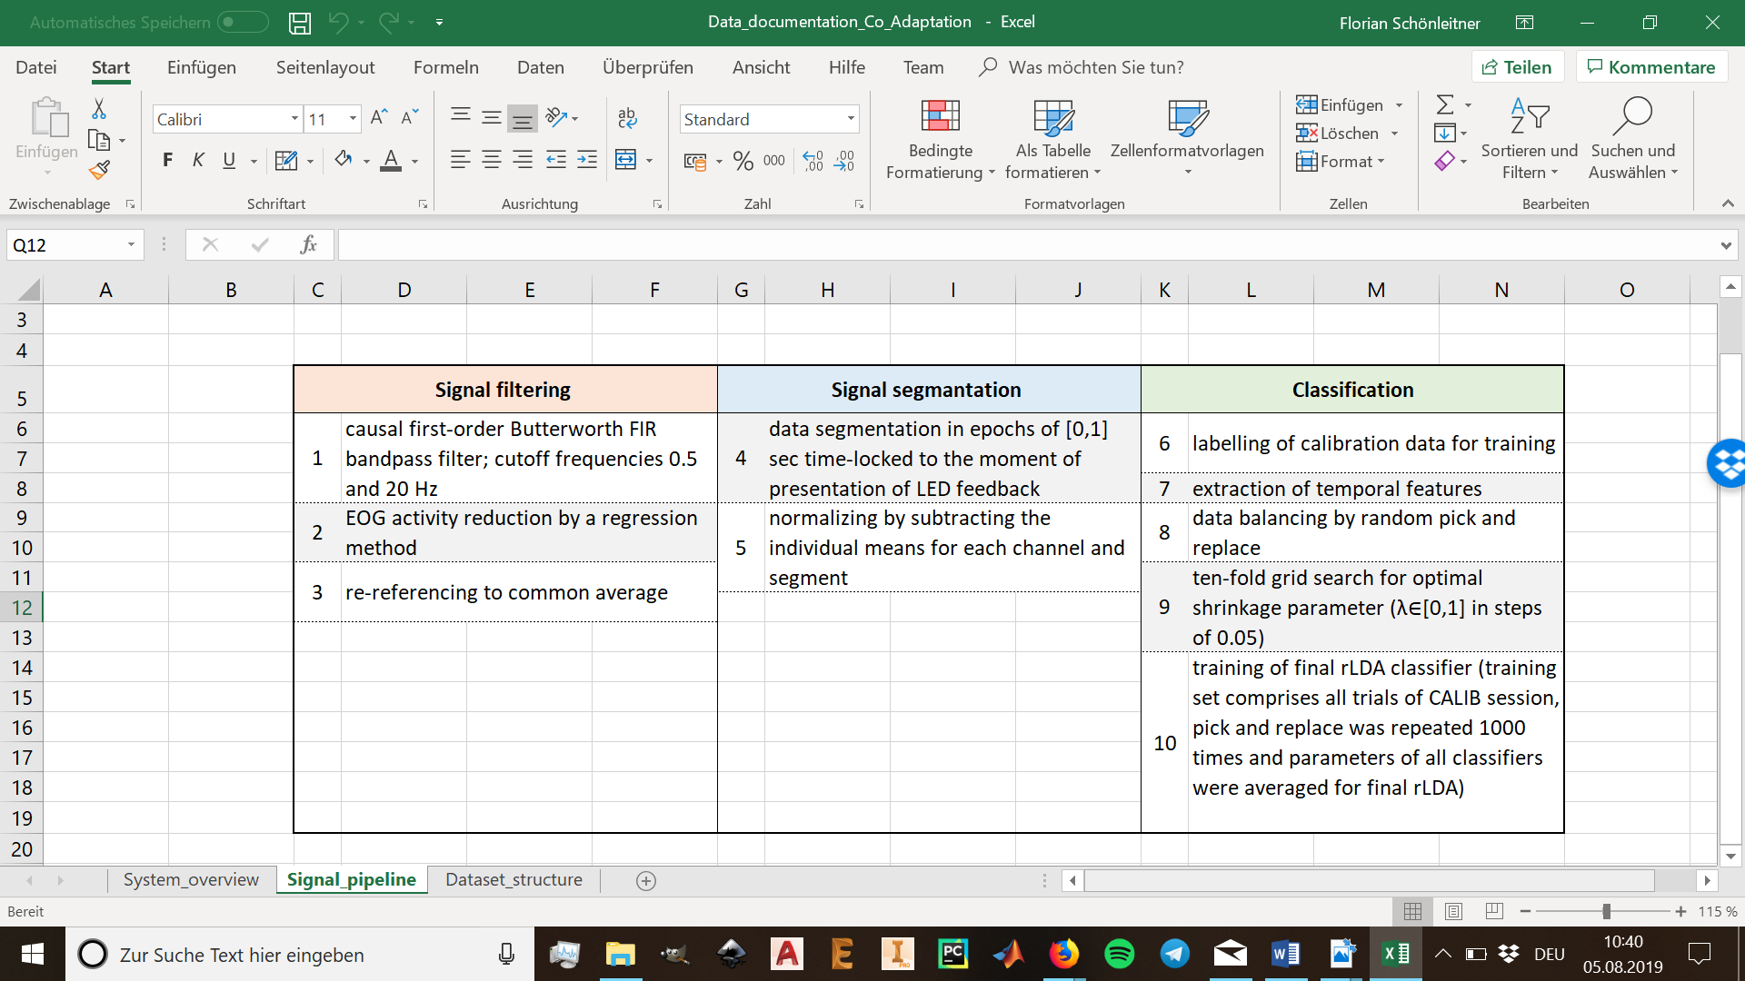For each subject, an individual ErrP-decoder was trained based on the data collected during the calibration session and later used in the online co-adaptation runs. The following steps were performed:

## ErrP-based agent policy adaptation

|  |  |
| --- | --- |
|  | The robot’s policy |
| t | count of current trial |
| R | Reward from ErrP decoder (-1 or 1) |
| α | Learning rate (α = 0.1) |
| *ai* | Action i |
| *sj* | State j |
| *k*=(1,*...*,*n*) | Action sequence in current trial |
| *n* | Depending on subject’s self-paced decision |

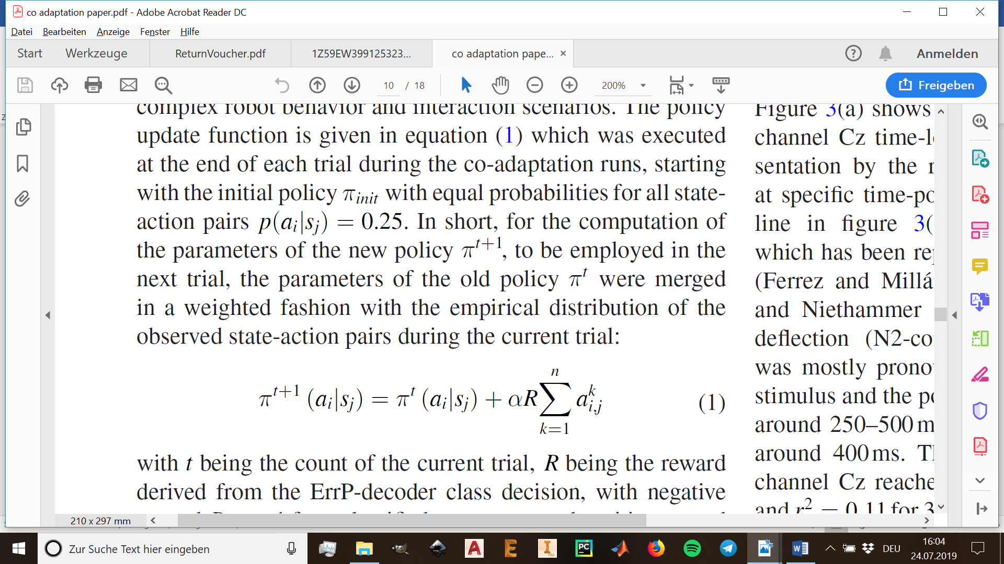For policy adaptation, a gradient method with the policy update function (1) was executed at the end of each trial during the co-adaptation runs. Truncation and normalization was performed after adding the policy gradient to the parameters of the old policy ­t: parameter updates of ­t+1 which exceeded the range were truncated to 0 and 1, respectively, and all actions per state were then normalized to sum up to one.

# Dataset structure

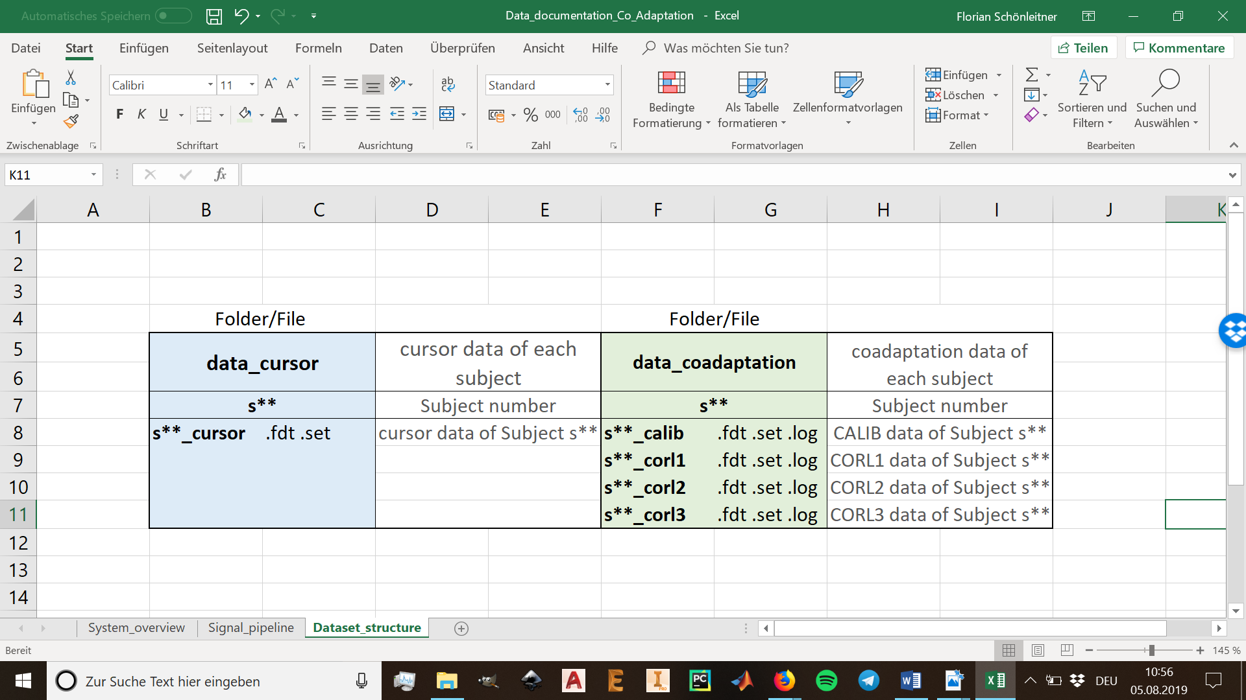The Dataset is structured in the folders **data_cursor** and **data_coadaptation**, where each folder is further subdivided in the respective subjects **s\*\***. The data itself is uploaded for each subject’s session as **.fdt**, **.set** and **_log** files.

# Trigger/Marker information in EEG data (data_coadaptation)

|  |  |
| --- | --- |
| 33025 | NAO decision – left object (not communicated to subject) |
| 33026 | NAO decision – middle object (not communicated to subject) |
| 33027 | NAO decision – right object (not communicated to subject) |
| 33028 | Human decision left object (response key “1”) |
| 33029 | Human decision middle object (response key “2”) |
| 33030 | Human decision right object (response key “3”) |
| 33031 | Feedback no error |
| 33033 | Feedback machine/human error |
| 33034 | NAO communicates chosen object via flashing LED |
| 33035 | NAO communicates chosen object via speaking out the name of the object |
| 33036 | NAO turns to object of interest |
| 33037 | NAO turns to other 1. object |
| 33038 | NAO turns to other 2. object |
| 33039 | NAO turns to human |

# Trigger/Marker information in EEG data (data_cursor)

|  |  |
| --- | --- |
| 33025 | Presentation of stimulus – left |
| 33026 | Presentation of stimulus – up |
| 33027 | Presentation of stimulus – right |
| 33028 | Response arrow key – left |
| 33029 | Response arrow key – up |
| 33030 | Response arrow key – right |
| 33031 | Feedback no error |
| 33033 | Feedback machine / human error |
| 33035 | Appearance of feedback (color-frame) |
| 33036 | Cursor back at screen center |
| 33037 | End of trial |